PHP & MySQL Project on

**FAST FOOD ORDERING SYSTEM**

Submitted by

Siddhesh Gadgil 5109

Pranav Phadke 5139

Zubin Kadva 5121

1. **Introduction**
   1. *General Information*

**Online food ordering** services are websites that feature interactive menus allowing customers to place orders with local restaurants and food cooperatives. Much like ordering consumer goods online, many of these allow customers to keep accounts with them in order to make frequent ordering convenient. A customer will search for a favourite restaurant, choose from available items, and choose delivery or pick-up. Payment can be amongst others by [credit card](http://en.wikipedia.org/wiki/Credit_card) or cash, with the restaurant returning a percentage to the online food company.

* 1. *Purpose*

We have chosen this topic to ease the searching activity of the users by integrating the various menu and facility of the restaurant and making it accessible to the users easily.

* 1. *Scope*
* This is a web application for a medium scale company.
* Increase the efficiency of ordering process.
* Improves the efficiency and effectiveness to manage physical inventory.
  1. *Technology Used*

For this project we have used following technologies -

This project utilizes **PHP** and **Xampp Server**has been used as implementation technologies.

**MySQL** has been used for Back-end implementation

* 1. *Domain Knowledge*
* To provide a user friendly e-shopping experience to online customers from a wider coverage area.
* To save the precious and productive time of the administrator this was earlier wasted in doing work manually.
* Easy ordering of food (Just at the click of the button)
* Pricelist available hence allows user to compare price of the items.

1. **Sitemap**



1. **Targeted users and their role**

*The Simple Unregistered User (SUU)*

The SUU can view the entire contents of the web site but will not be able to place an order or use the services of the web site

*The Registered Customer*

The customer can login and select the food item he wishes. After selecting the item from various categories, final bill is generated and the order is placed.

*The Site Administrator*

The main head of the site is the administrator who has the capability to add / delete an item. These changes will be automatically updated on the menu page, thus allowing full flexibility.

1. **Programming Details**
   1. *Pages and Functions*

This website includes the following pages. Their functions are described also.

*The Home Page (www.pizzanmore.com)*

The first shot at the human eye is the attractive and catchy home page. It presents the user with a simple overview of our services through an auto scroll image slider, below which, a customer can log in using his name and password or new user can register themselves.

*The Registration Page (www.pizzanmore.com/userregistration.php)*

This page provides the user with a registration form which has to be filled by a new customer prior to using the services that the site has to offer.

*The Fast food menu category wise (www.pizzanmore.com/menu.php ||menu_burgers.php || menu_sideorders.php || menu_refreshments.php)*

These are the dynamic pages which present the user / customer with a detailed view of our items which includes its name, description, rate and also an image representing the pictorial representation of the item.

*The start ordering page (www.pizzanmore.com/startoredering.php)*

This page presents a list of the various items offered by us. Again this is a dynamic page. A registered customer can place an order by simply checking the boxes. Note that an unregistered user will not be able to do so.

*Viewing the order*

Once the user selects one or more items, he is taken to the page where he will enter the quantity for the corresponding item.

Once this is done, a final auto generated bill is displayed consisting of the usual stuff with a tabular representation of the item name, quantity, rate and total and not to mention the grand total.

*Administrator Privileges - Addition / Deletion of an item*

If the user logging in is an administrator, he is given additional privileges which allow him to add a new item, and delete an existing item. The additions / deletion changes will be updated in the category wise menu and the full menu

*Static pages*

*About us*

This page provides a brief introduction about our services

*Contact us*

This page provides certain contact details and mail addresses where you can send in your queries

*Terms and conditions*

This page consists of the terms and the ordering conditions which should be followed by the user

*Privacy Policy*

This is a soothing page as the user is explained how the site uses his private data

* 1. *Database Structure*

The project consists of the following tables stored within the database

*The `Products` table*

|  |  |  |
| --- | --- | --- |
| **Column Name** | **Data type** | **Functionality** |
| product_id | varchar(10) | The Product ID |
| product_name | varchar(50) | The Product Name |
| product_description | text | The Product Description |
| product_category | varchar(50) | The Product Category |
| product_price | int | The Product Pricing Scheme |
| product_image | varchar(50) | The Image Path |

*The `Customers` table*

|  |  |  |
| --- | --- | --- |
| **Column Name** | **Data Type** | **Functionality** |
| customer_id | int | The Customer ID |
| first_name | varchar(50) | The Customer Name Credentials |
| middle_name |
| last_name |
| residence | bigint(150) | The Customer Contact Details |
| cell_phone |
| email | varchar(50) |
| room_number | varchar(10) | The Customer Address Details |
| floor_number |
| street | varchar(50) |
| city |
| pincode | int |
| username | varchar(50) | The Customer Logon Credentials |
| password |
| secret_question | The Customer Password Recovery |
| secret_answer |
| isadmin | varchar(10) | Is he admin? |

*The `<customer_id>_<first_name>_orders` table*

|  |  |  |
| --- | --- | --- |
| **Column Name** | **Data Type** | **Functionality** |
| product_id | varchar(10) | The Product ID |
| product_name | varchar(50) | The Product Name |
| product_price | int | The Product Price |
| quantity | The user quantity |
| total_price | The total price |

**V. Screenshots**

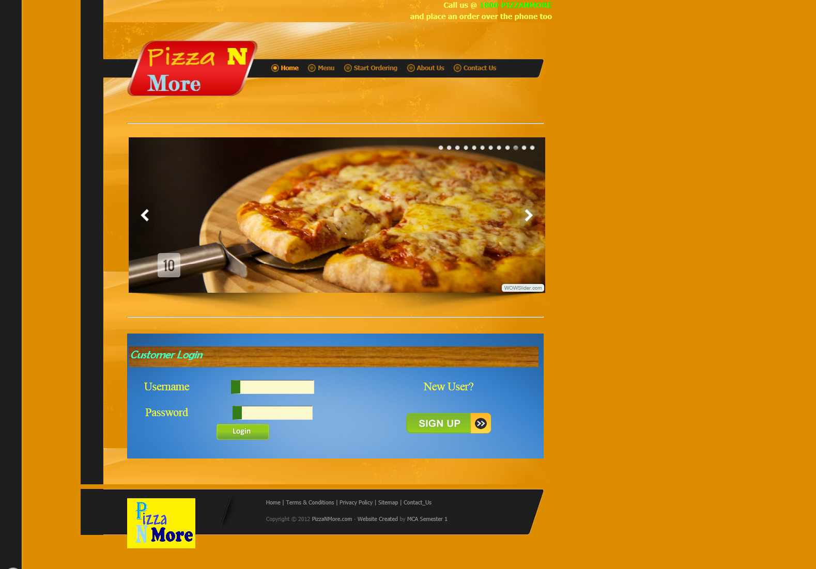

The PizzaNMore.com Home

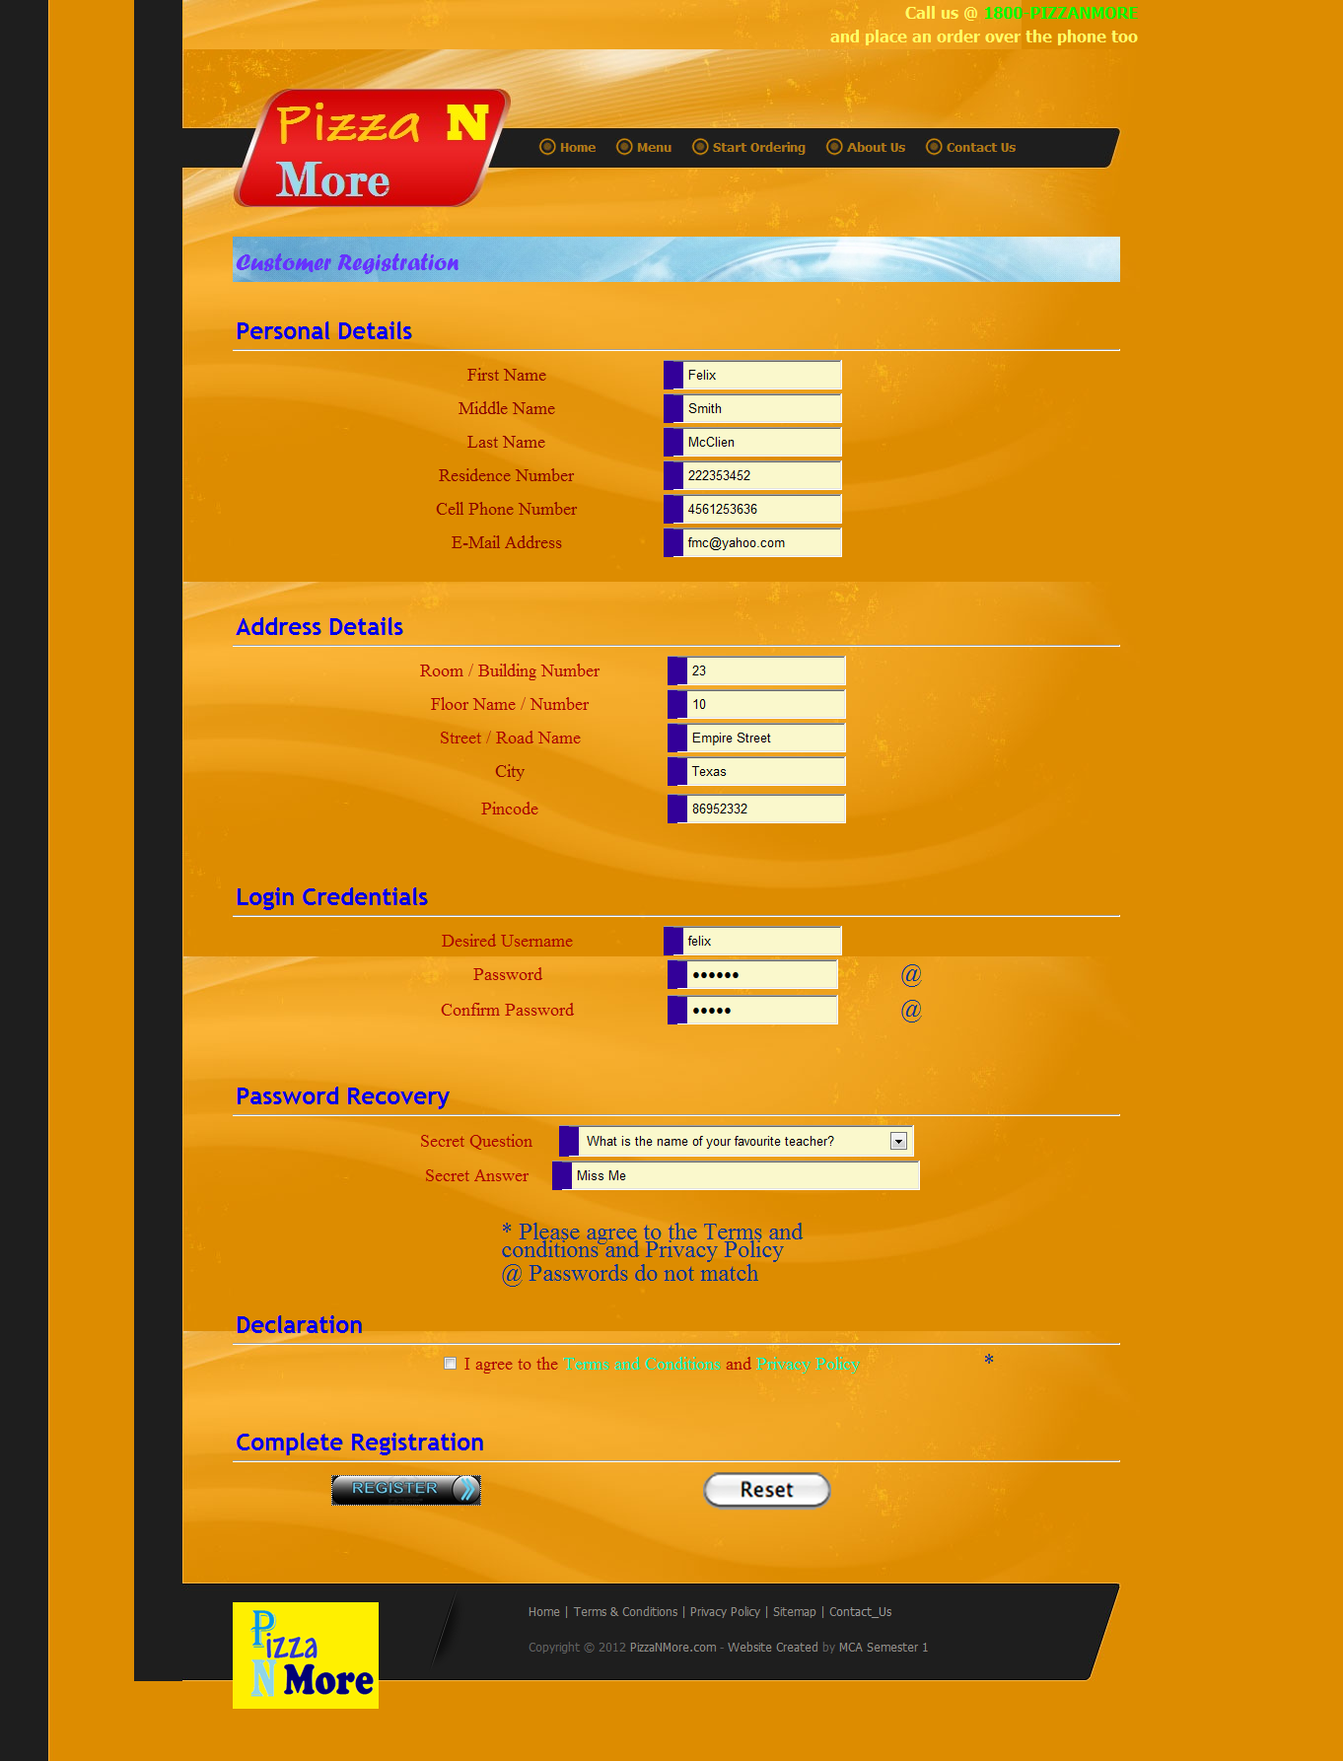

The Registration Page

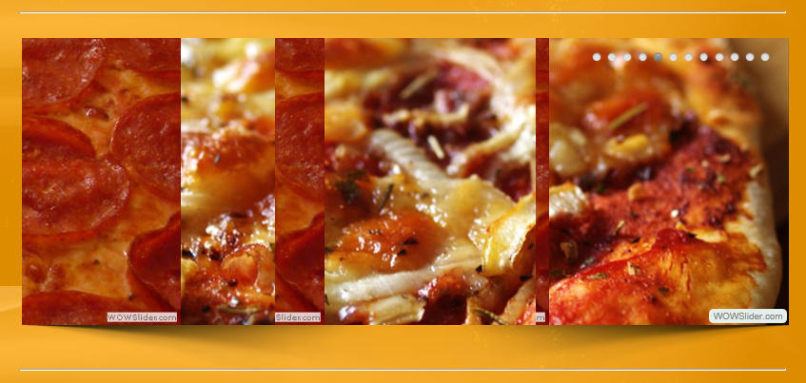

The automated image slider

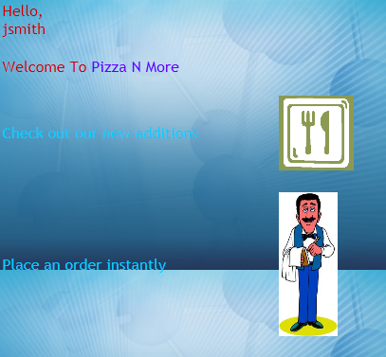

Registered User after login



If the user is an admin

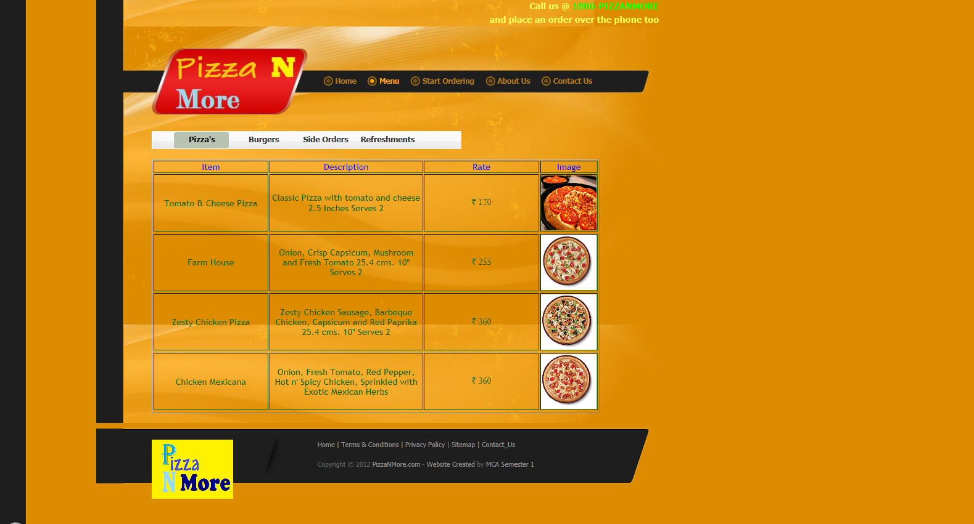

Menu Category 1 – Pizza’s

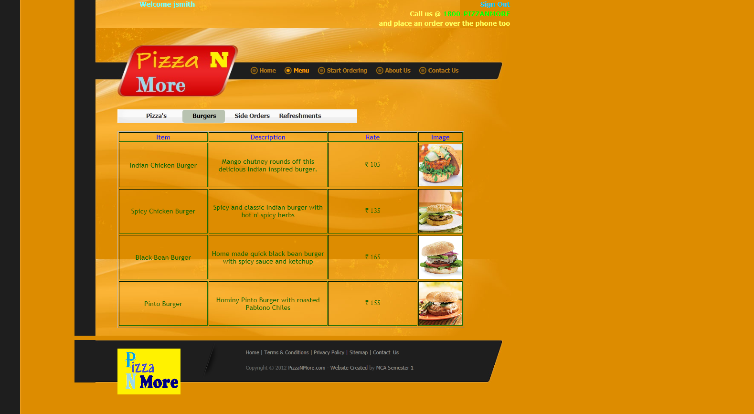

Menu Category 2 –Burgers

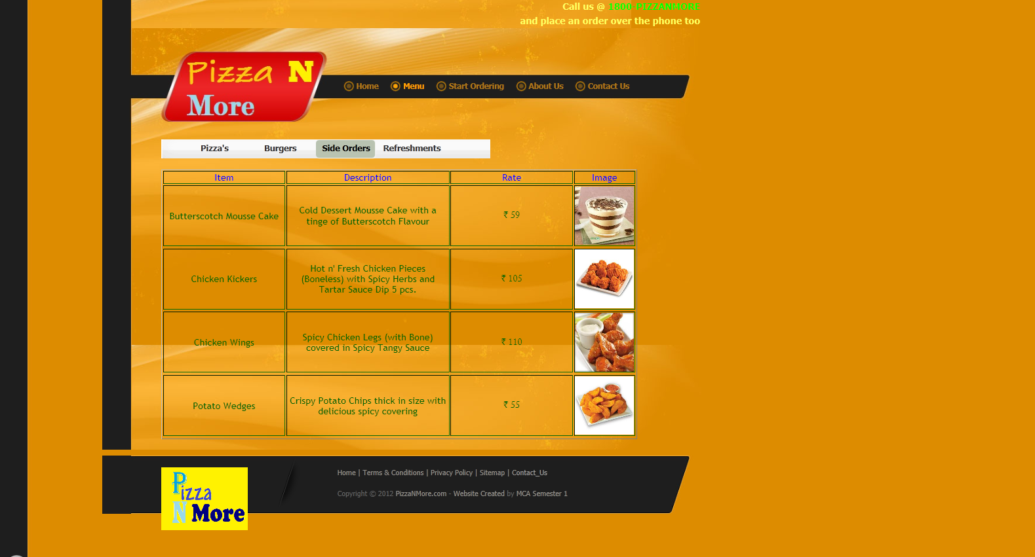

Menu Category 3 – Side Orders

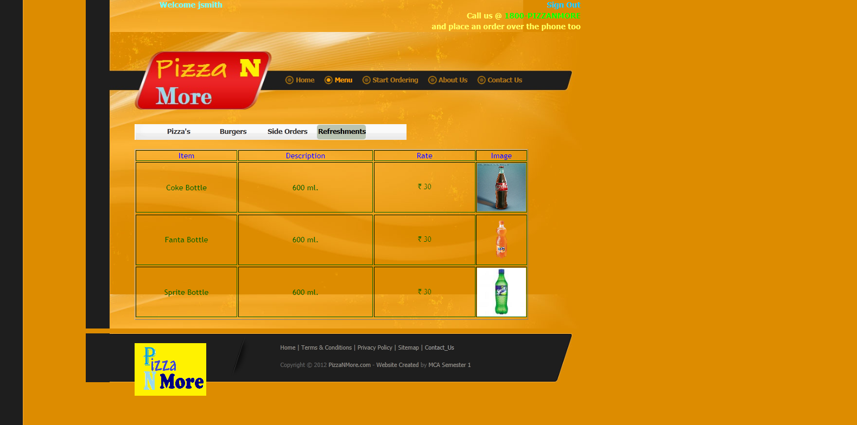

Menu Category 4 – Refreshments

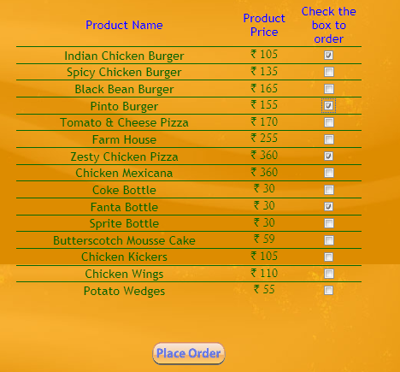

The Start Ordering Page for a logged in user

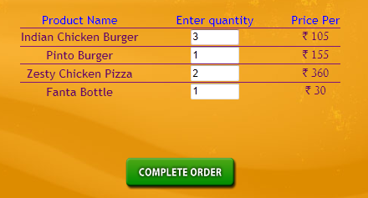

Viewing the order details

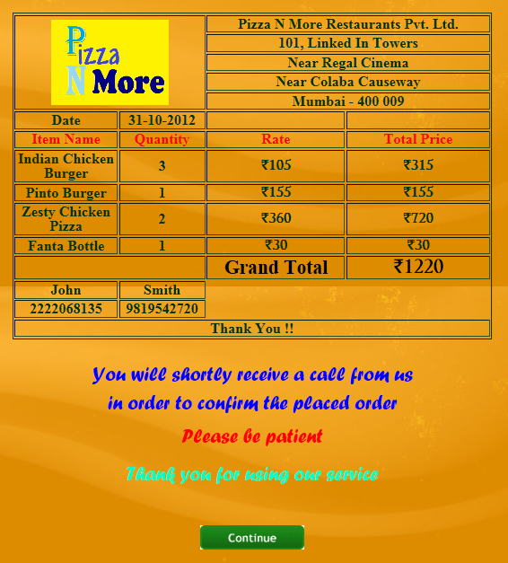

Generation of an automated final cheque

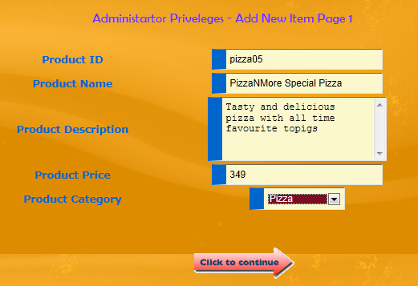

Administrator Privilege – Adding a new item Page 1

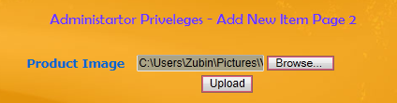

Administrator Privilege – Adding a new item Page 2

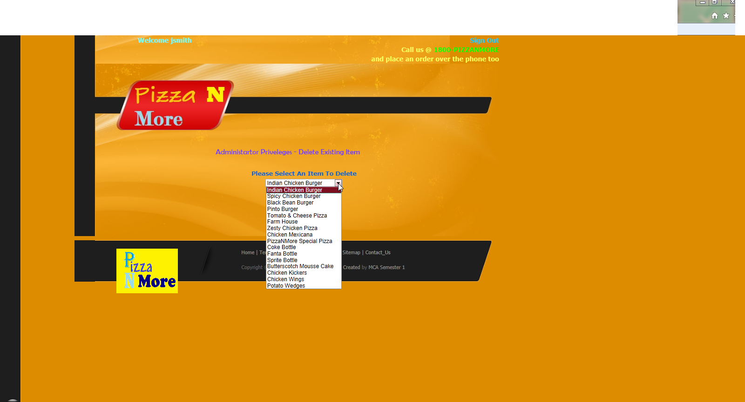

Administrator Privilege – Deleting an existing item

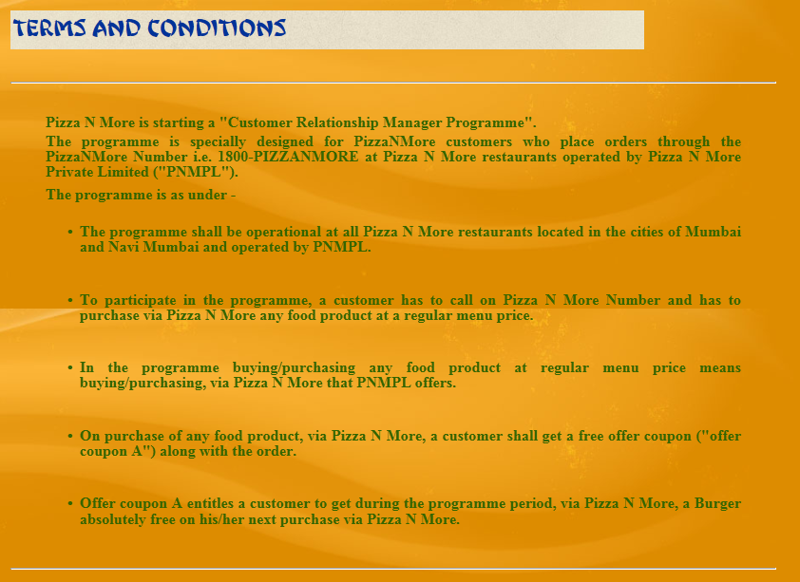

Terms and Conditions

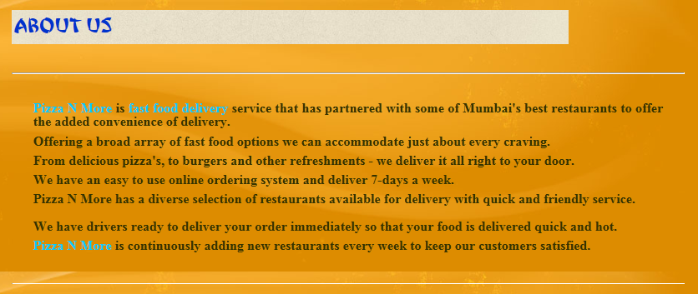

About Us



Contact Us

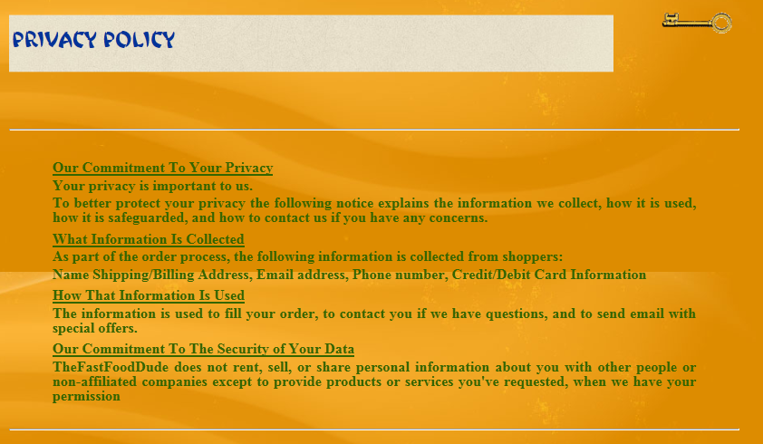

Privacy Policy

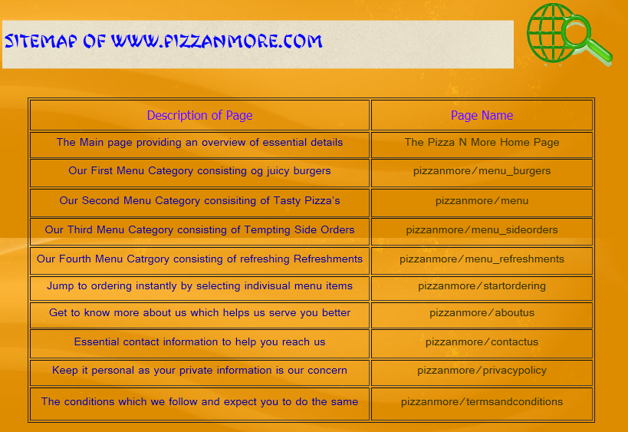

The Sitemap represented in a tabular structure

1. **Limitations and Future Enhancements**

*Limitations of the existing system*

For the manual system, the administrator is responsible for all the data, all inputs are made manually which increase completion time of work; also the manual system had a variety of errors.

*Time Consumption*

Time required for gathering, processing, storing of data would be time consuming

*Manual systems lack accuracy*

It is a human tendency to do mistakes. Small mistake would also affect the accuracy of data about customers.

*Maintenance of the data of the customers*

The organization is facing problems in maintaining the records of the customers. There is no proper grouping of the details about data due to which maintaining the data becomes hectic for the organization.

*Updating the records is difficult*

A record cannot be easily updated in the current system owing to the amount of time required to navigate through the seams of records. So in order to update a record the personnel has to spend a stupendous amount of time in drilling down the data thus making the updating of data even more tedious.

*It is difficult to generate reports*

All the important reports that are generated by administrator fail to maintain the reports in a consistent state.

*Future enhancements*

We believe in one line “There is always an inch more to build”.

This means, our website can be enhanced, and will be enhanced further more.

We were bound by certain criteria such as time, money, syllabus permission like professional talent and work experience.

But positively, without these bounding criteria, we would like to enhance this software project and empower it with many more functionalities.

Some functionality our future enhancement includes.

• Inclusion of stringent security.

• Integration with the advanced web.

• User star ratings.

Our current project is a sincere effort to balance all the current limiting criteria but we hope that we can add above functionalities to our current project.

1. **Bibliography**

